**HOW TO LOAD DATA INTO HIVE**

**1. Launch HIVE**

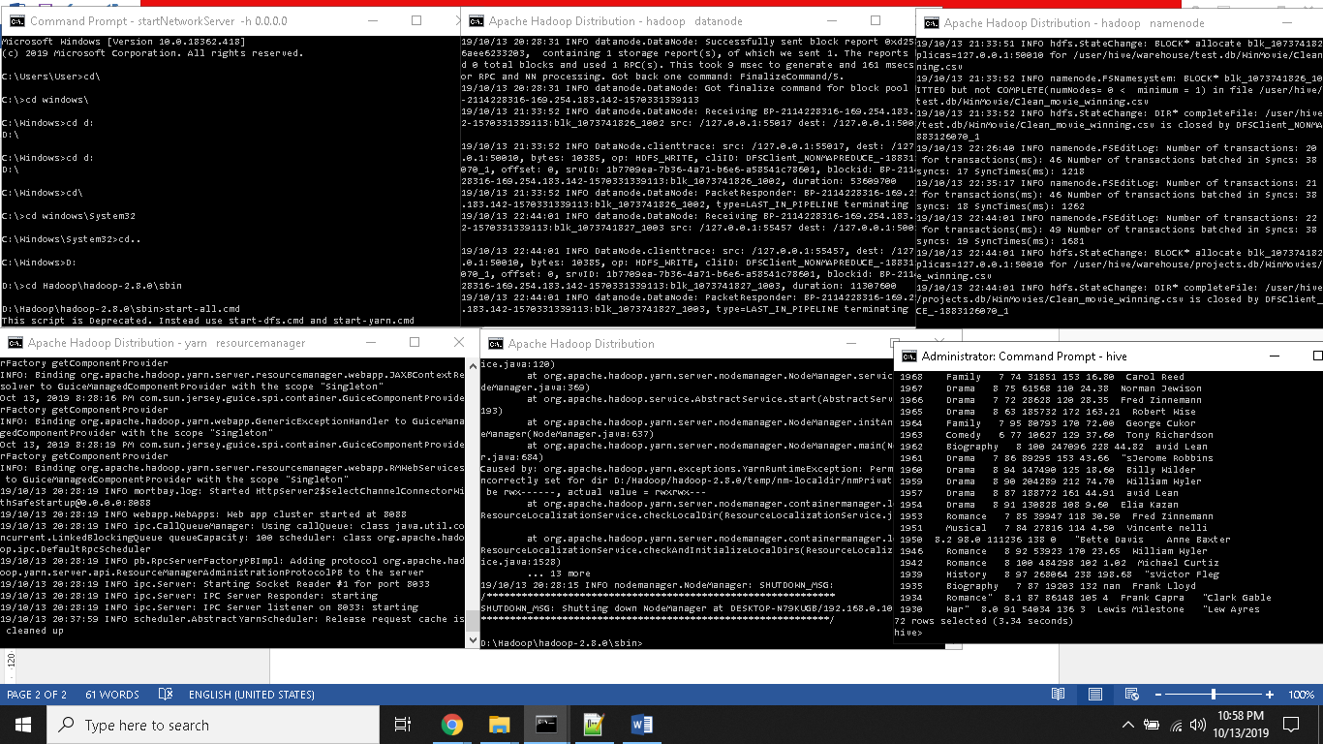

Figure 1.1 Launch Hive.

**2. Create database**

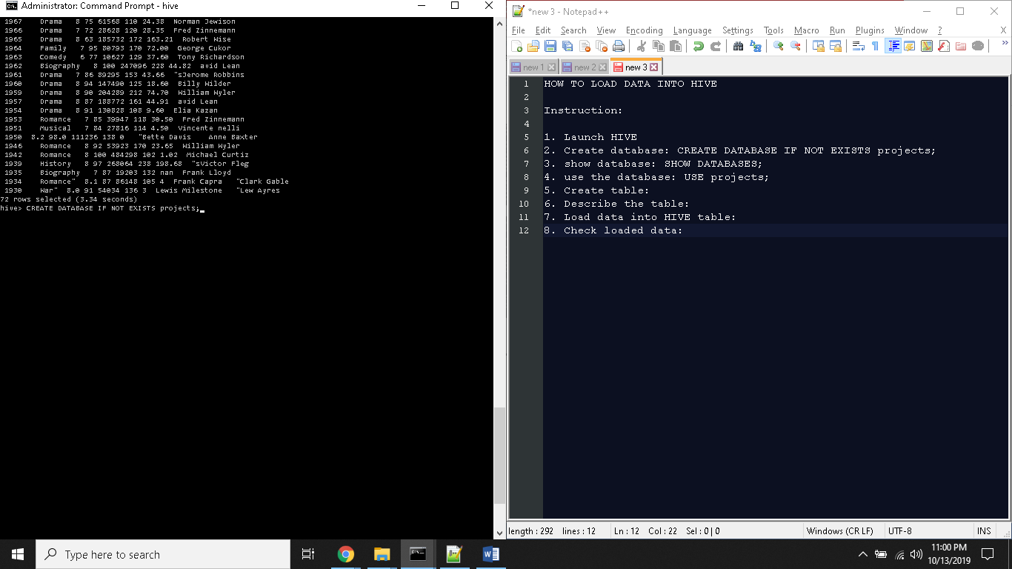

Figure 2.1 Create database using “CREATE DATABASE IF NOT EXISTS projects;” command.

**3. Show database**

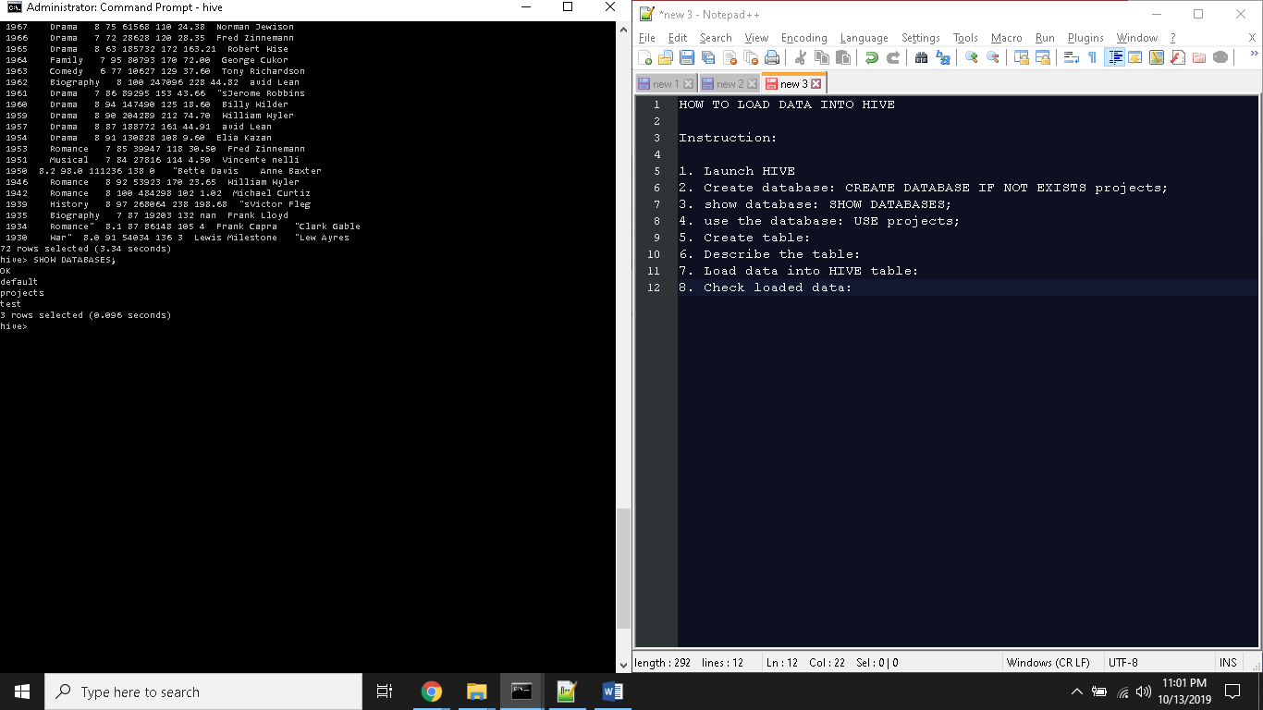

Figure 3.1 Check database existence using “SHOW DATABASES;” command.

**4. Use the database**

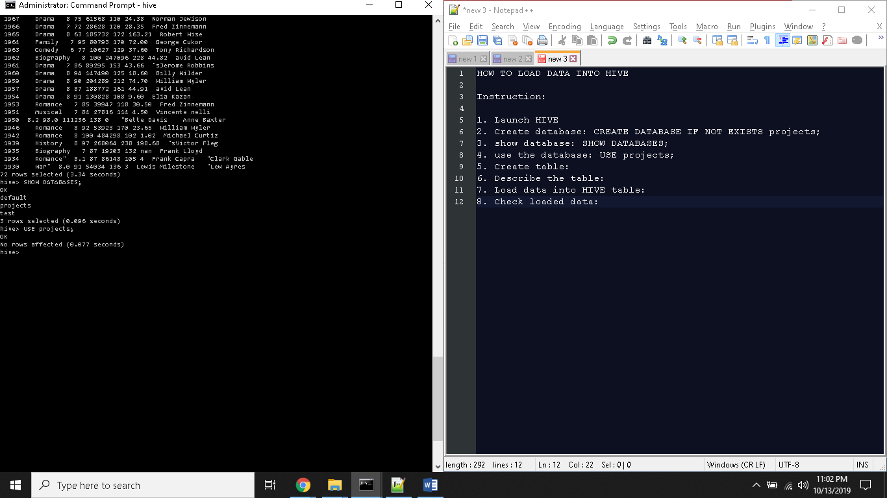

Figure 4.1 Use the database with “USE projects;” command.

**5. Create table**

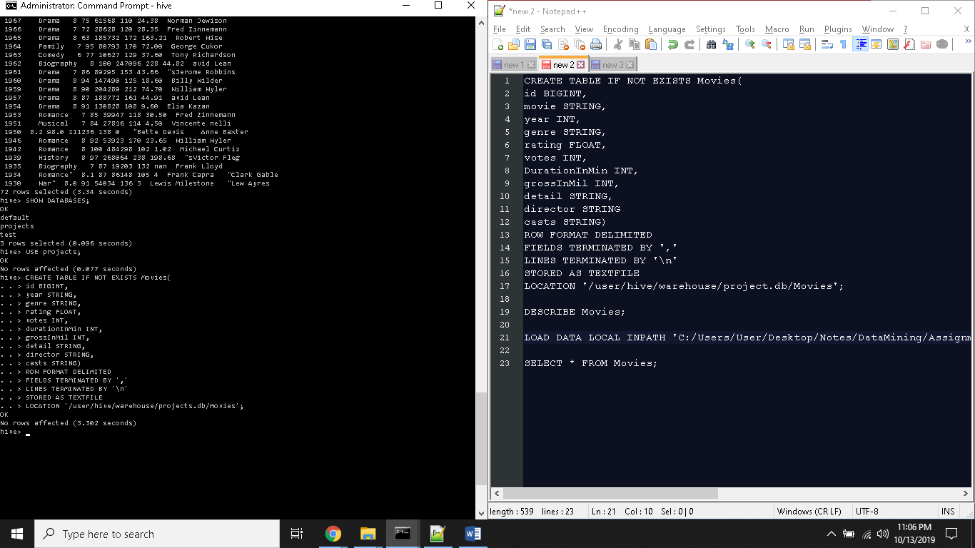

Figure 5.1 Create table using “CREATE TABLE”commands.

**6. Describe the table**

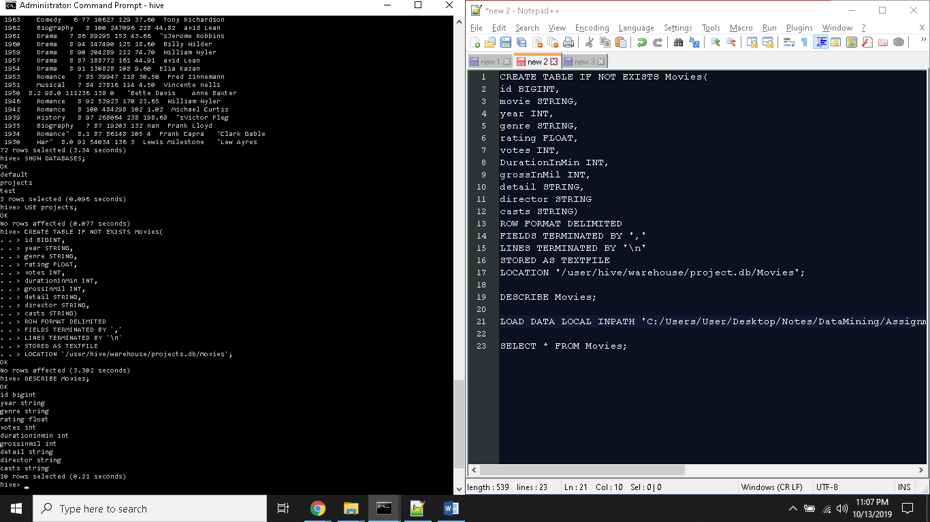

Figure 6.1 Describe table using “DESCRIBE Movies;” command.

**7. Load data into HIVE table**

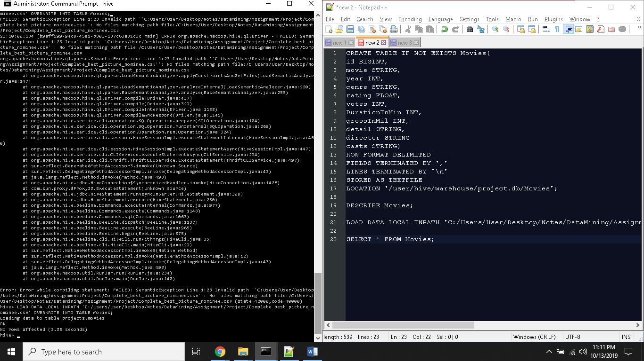

Figure 7.1 Load data into hive using “LOAD DATA LOCAL” command.

**8. Check loaded data**

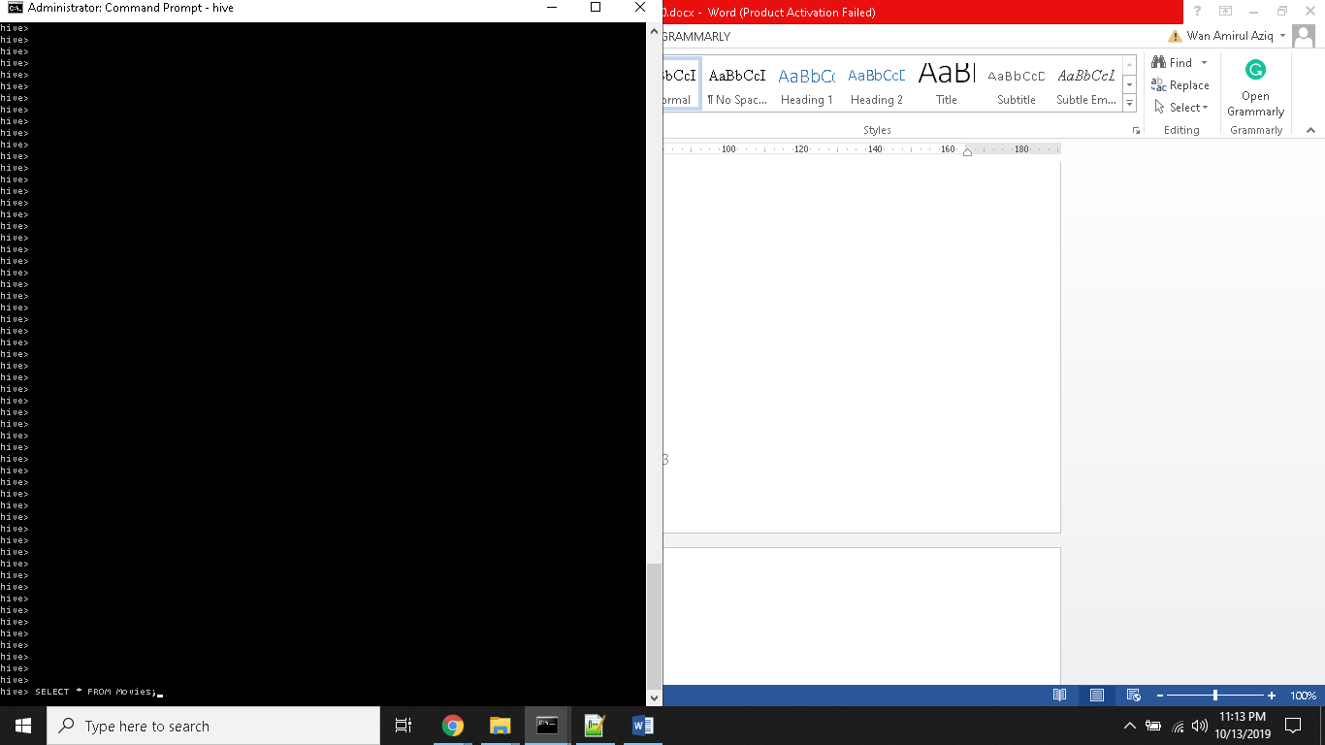

Figure 8.1 Check loaded data using “SELECT” command.

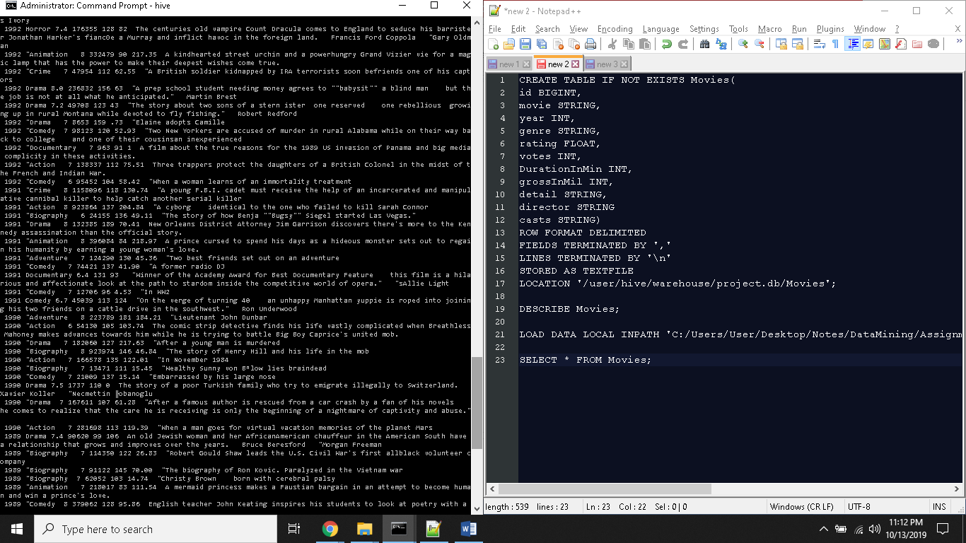

Figure 8.2 All loaded data been showed.

**9. Youtube and Github Links**

* Youtube
  + Part 1 – https://youtu.be/hlBzdzxqtsY
  + Part 2 - https://youtu.be/AuWGCjGJ3EM
* Github
  + https://github.com/OoiLiJuan/DataMiningProject